**Assignment 3: Enable Snapshot backup and restoration and define retention period**

Method 1:

Step1: Select a DocumentDB cluster, go to Actions->take snapshot

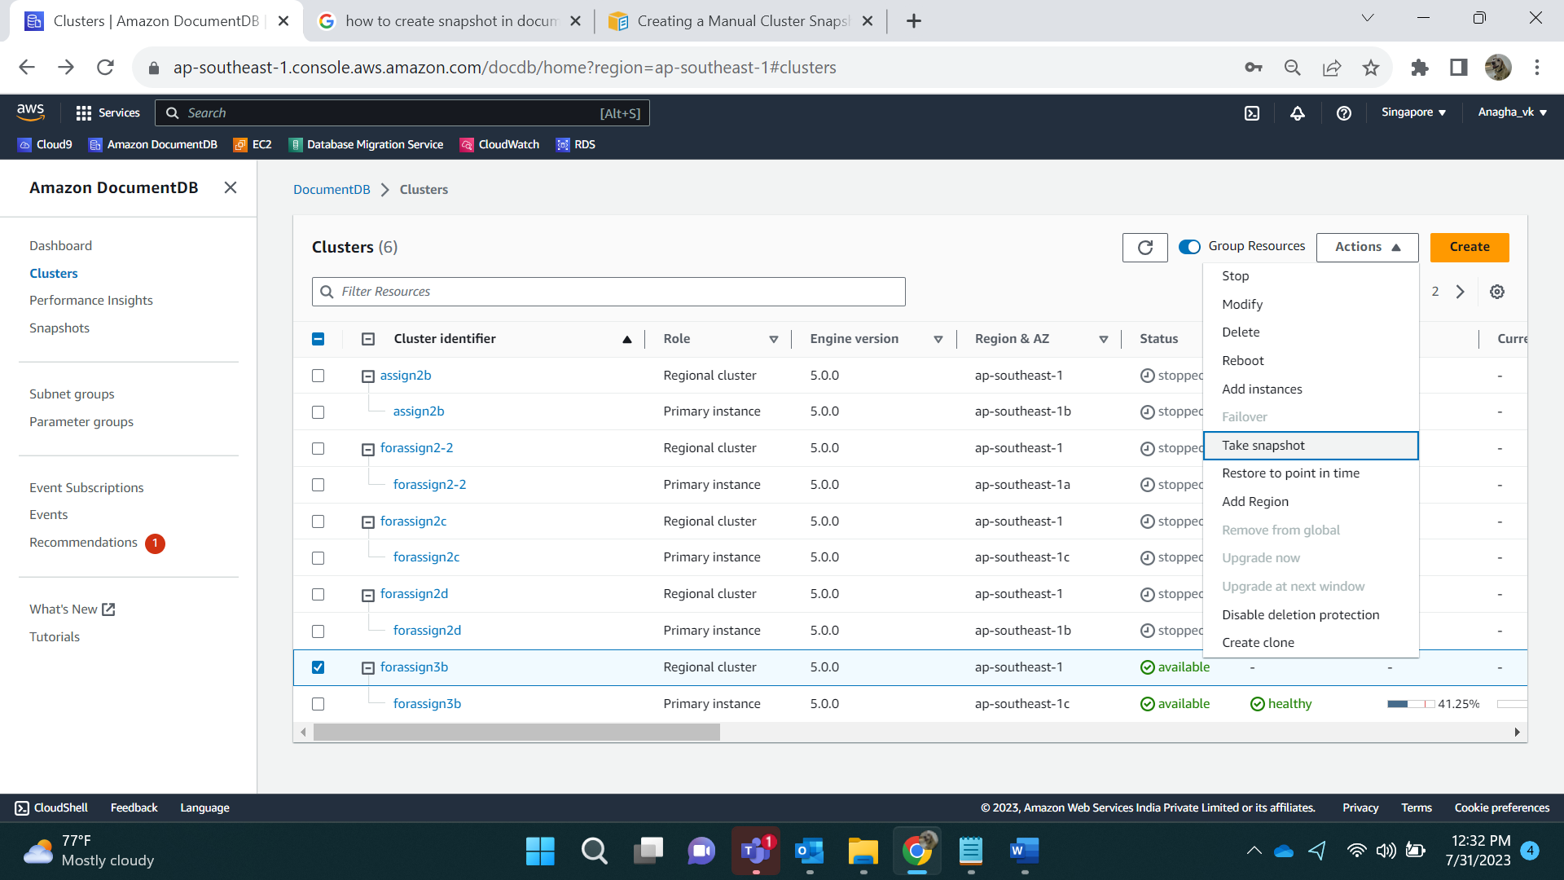

Enter name and click on create.

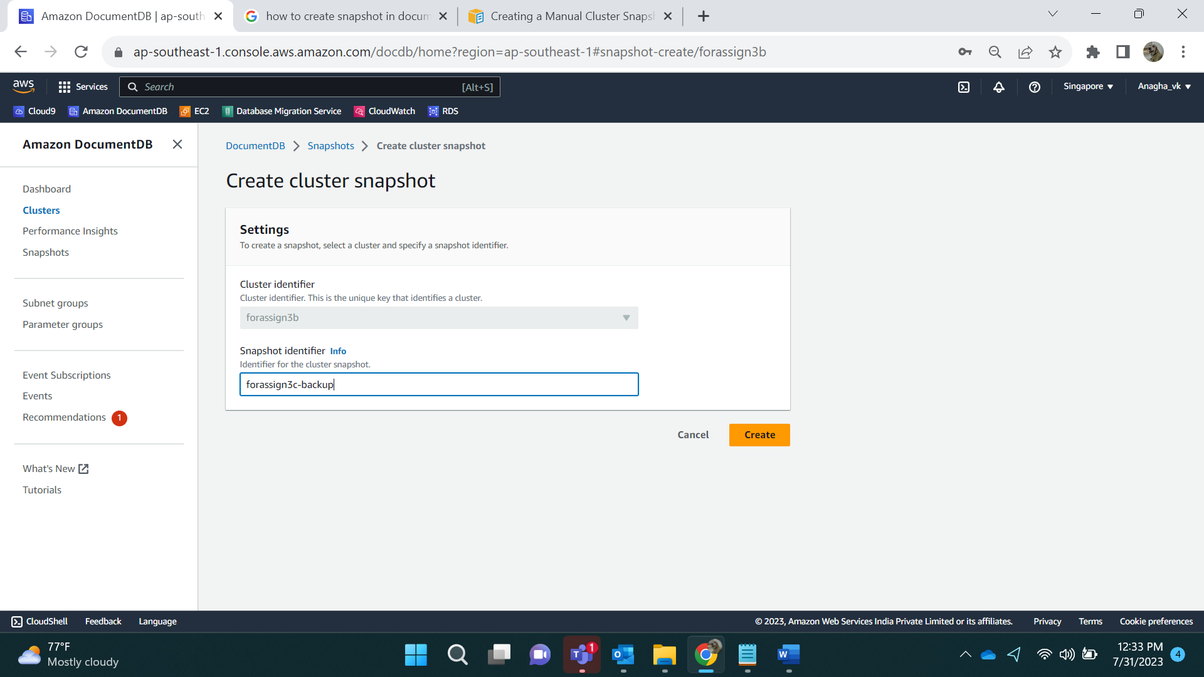

Go to Actions->Delete

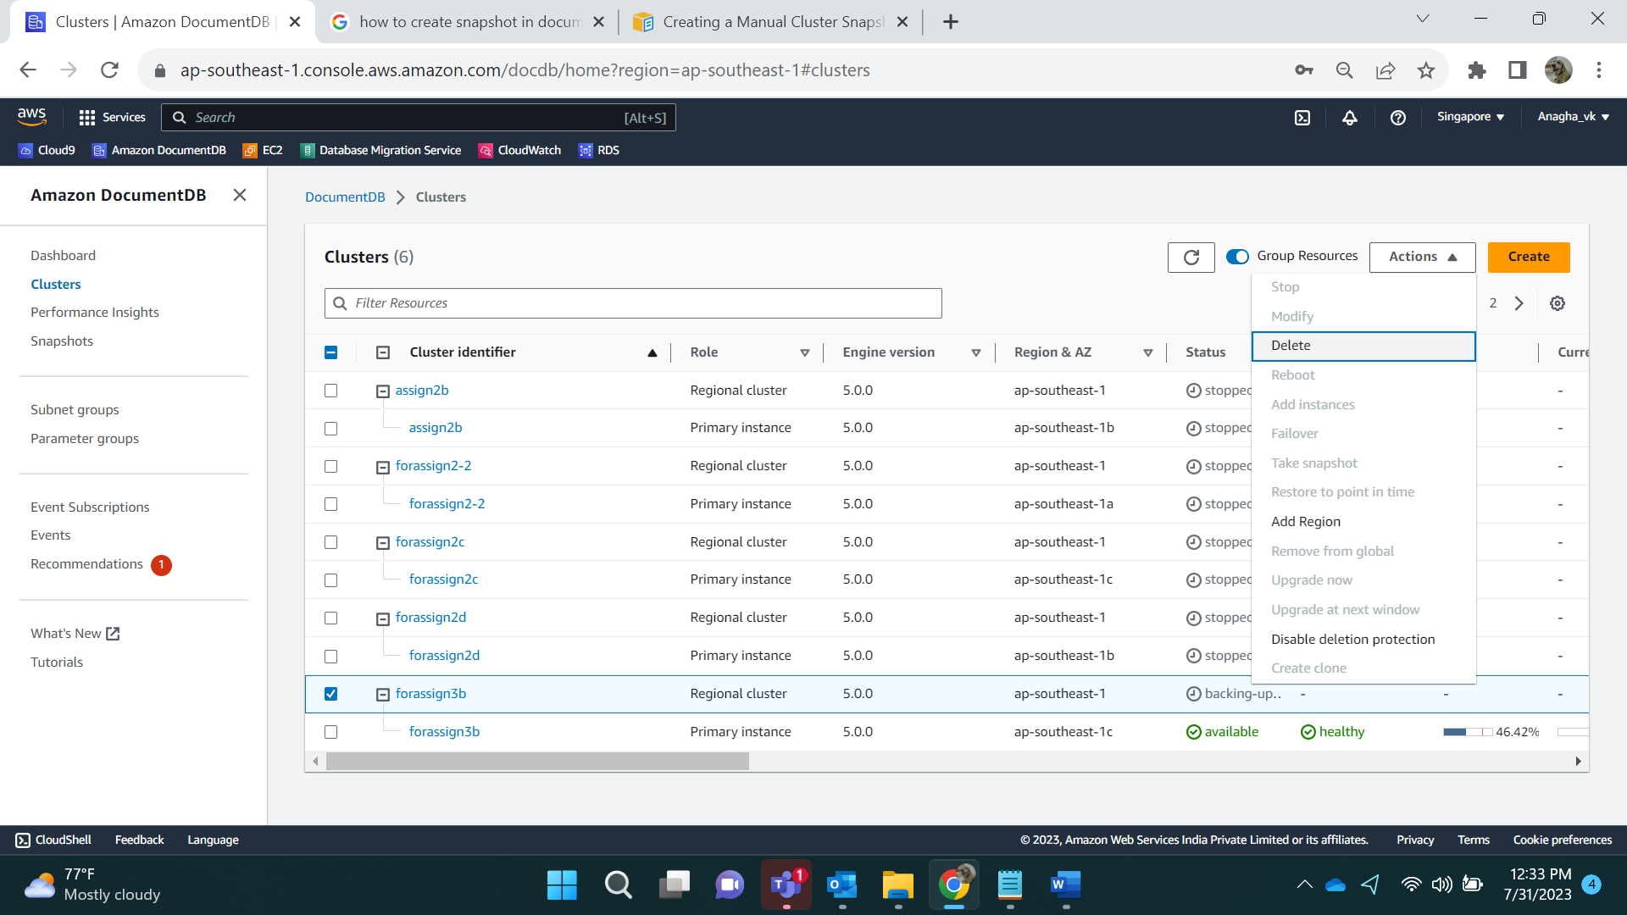

We need to Disable Delete Protection and then delete. Apply immediate changes.

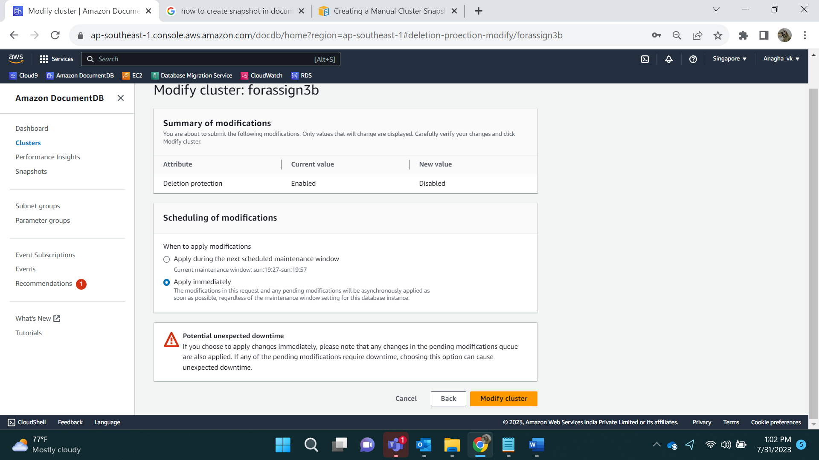

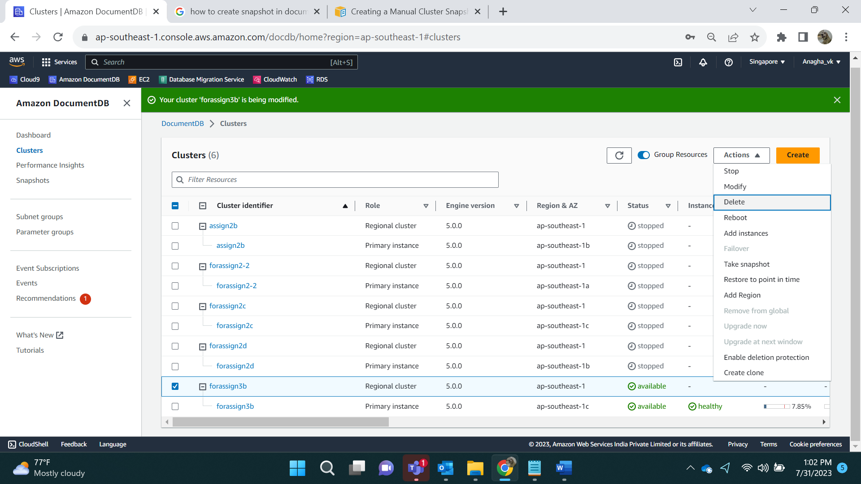

Method 2:

Before deleting, it will ask if we want to take a snapshot. We can enter a name for this.

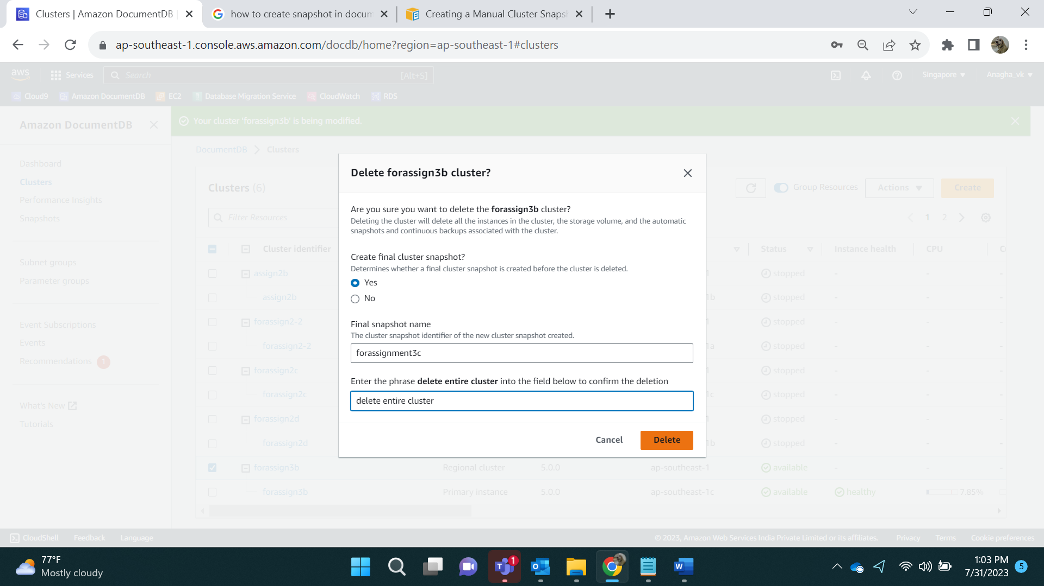

Result:

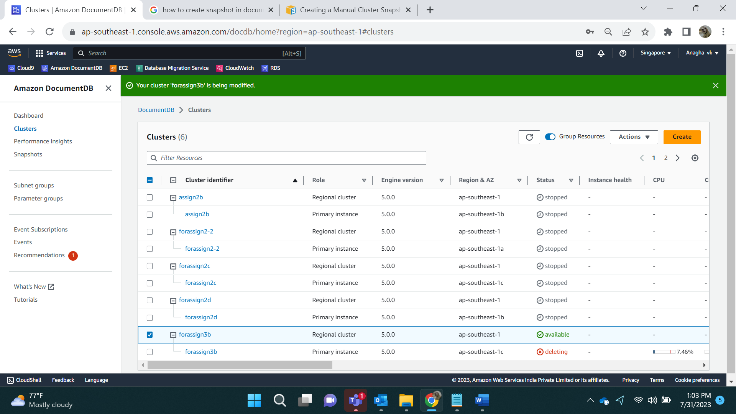

After Deleting:

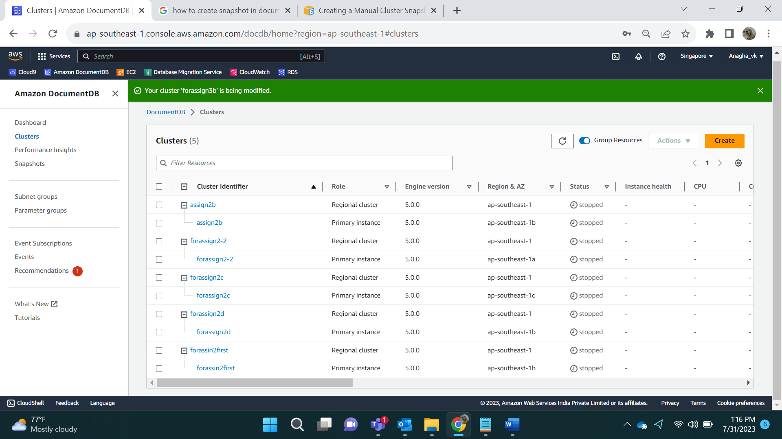

**Restoring the snapshots can be done in existing clusters also, but in this example, I have deleted the cluster.**

Go to Snapshots.

We have 2 snapshots:

1. Forassign3c-backup
2. Forassignment3c

Select any 1 of the 2 snapshots we have taken. Go to Actions->Restore.

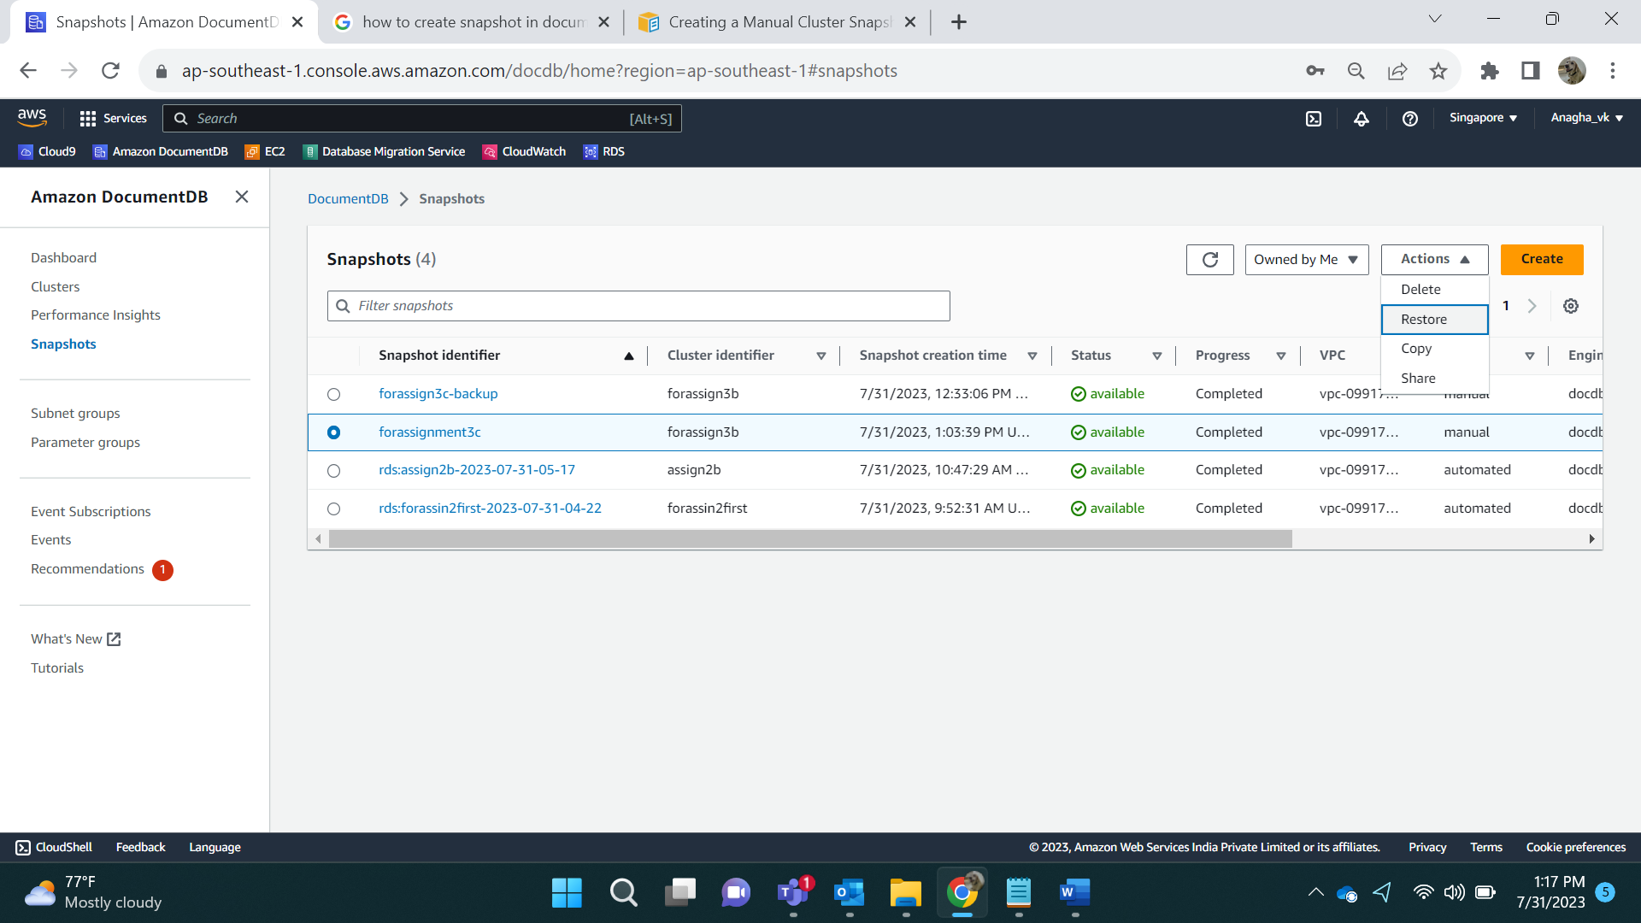

Enter the Name, number of instances as 1 and click on Restore Cluster.

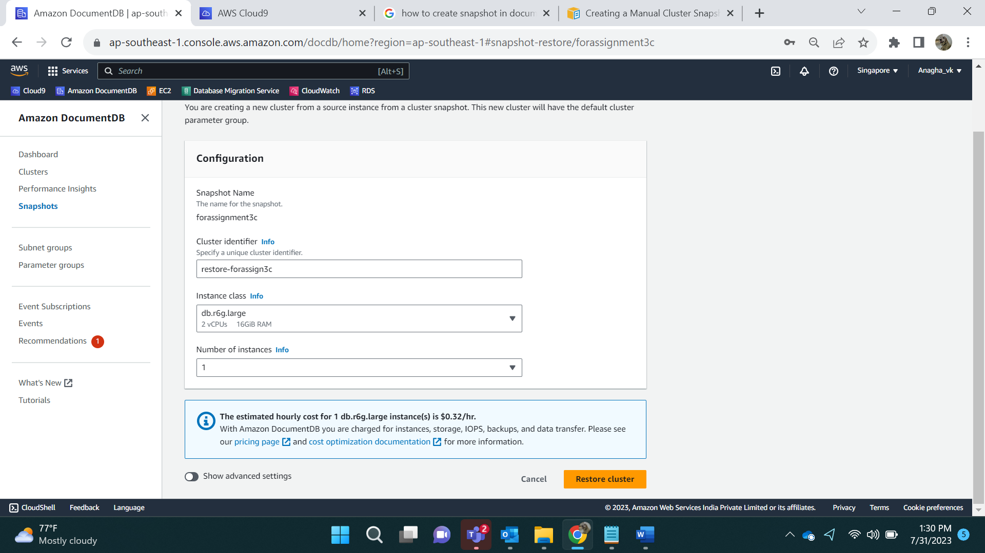

Result: Cluster is being created:

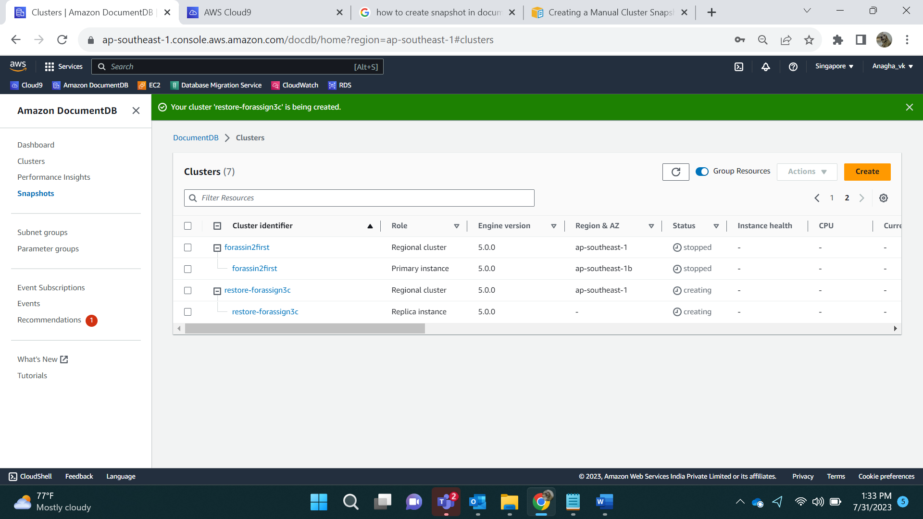

Result:

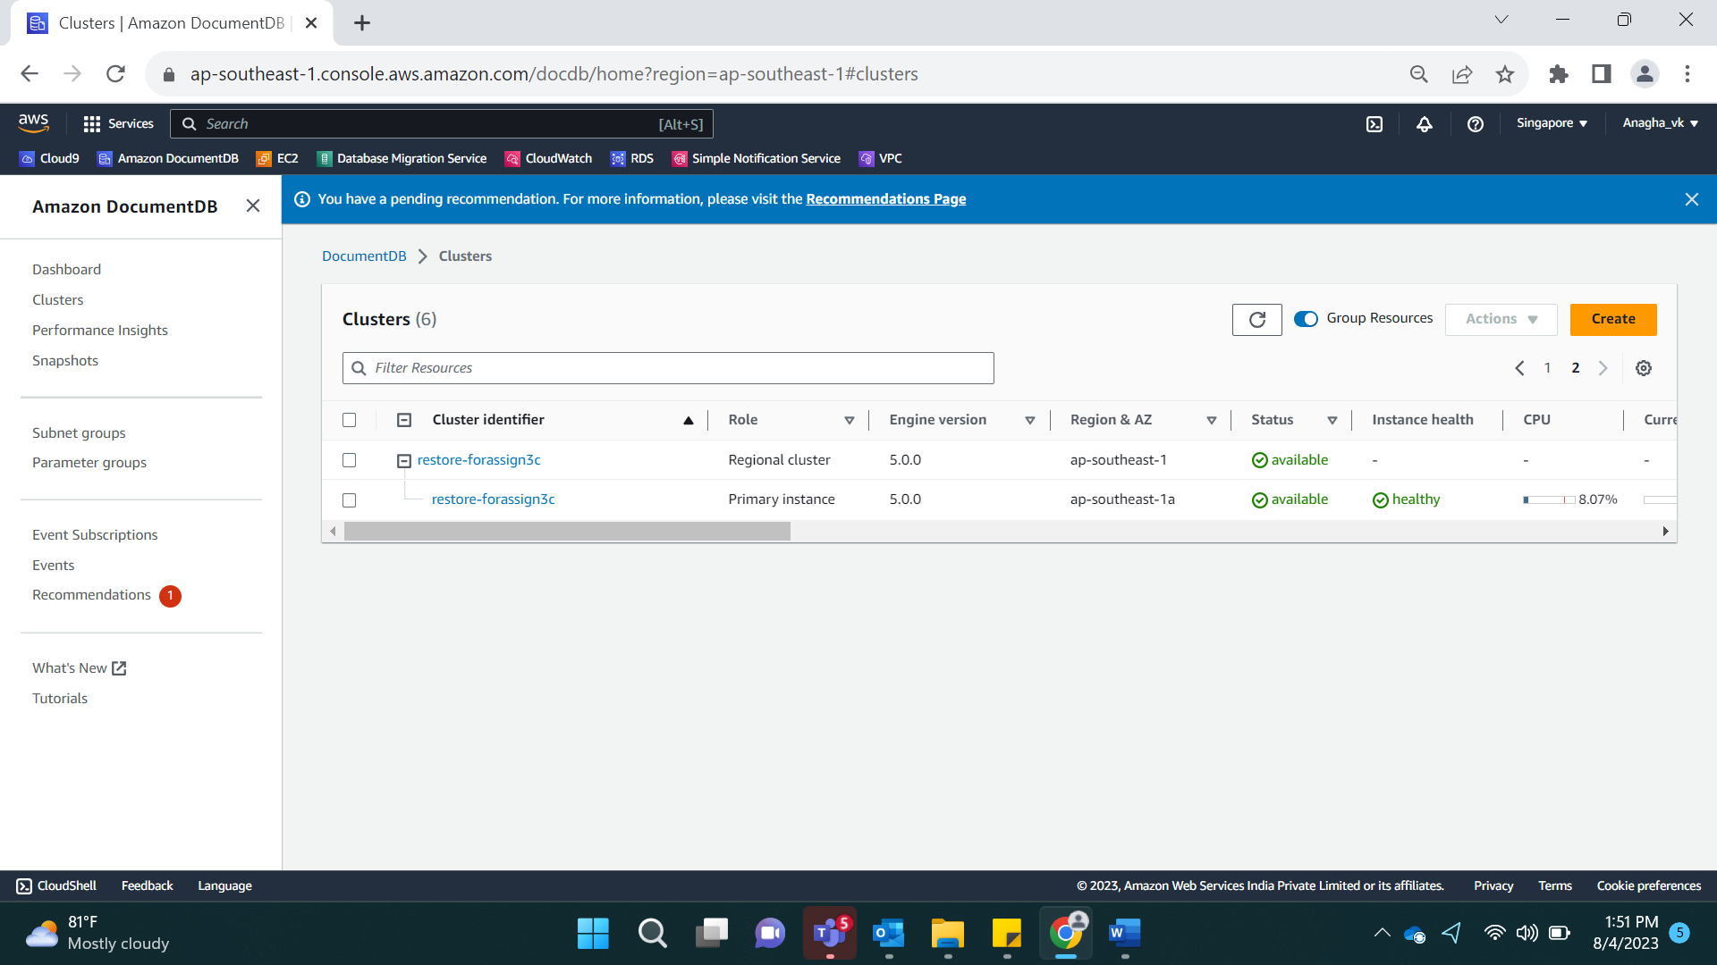

Connecting via Cloud9 and checking data

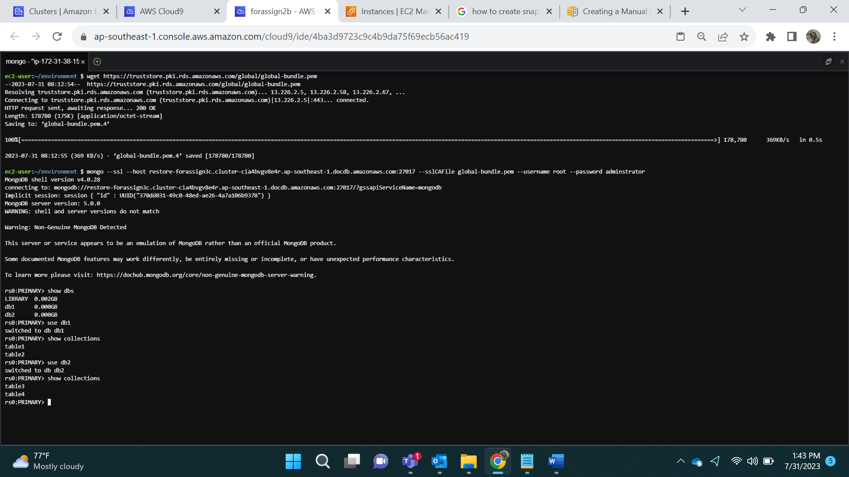

**Retention Period**

Modify retention period:

Go to cluster and modify the cluster. We can see the Backup module. Default value is 1.

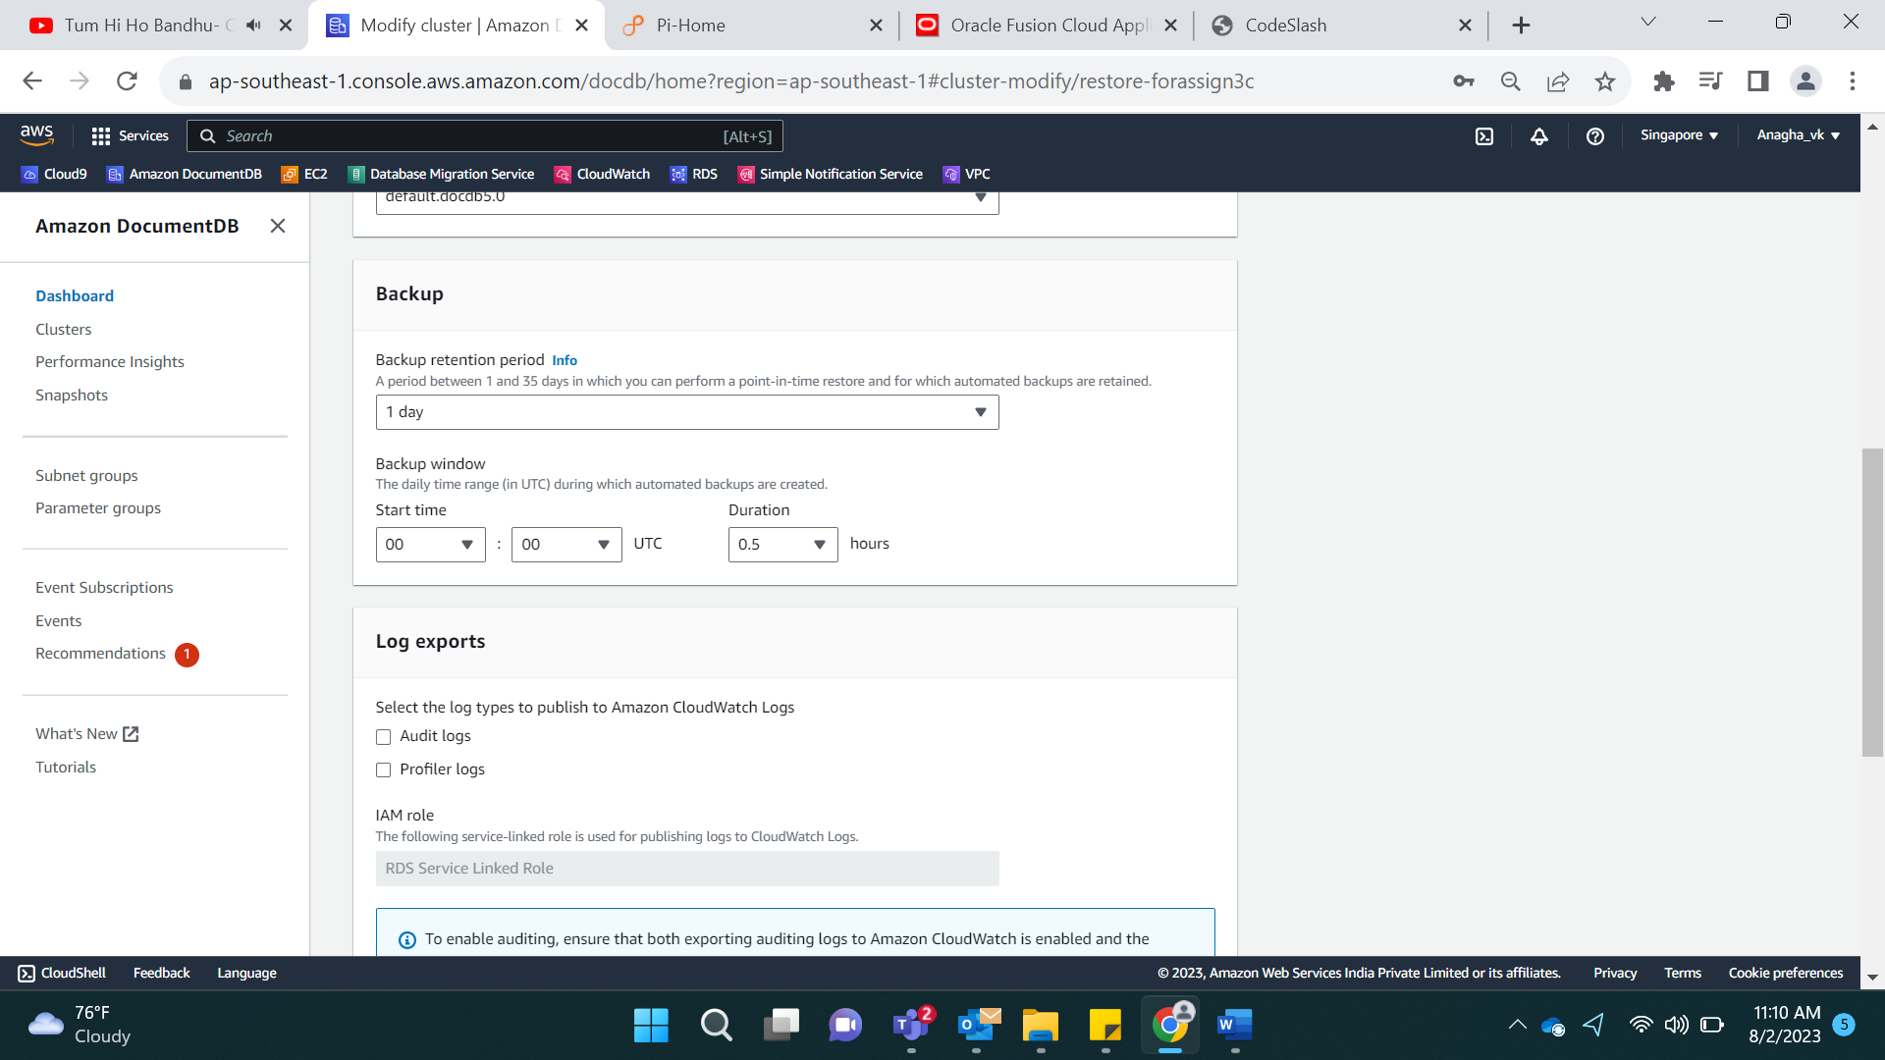

Changing it to 5 days:

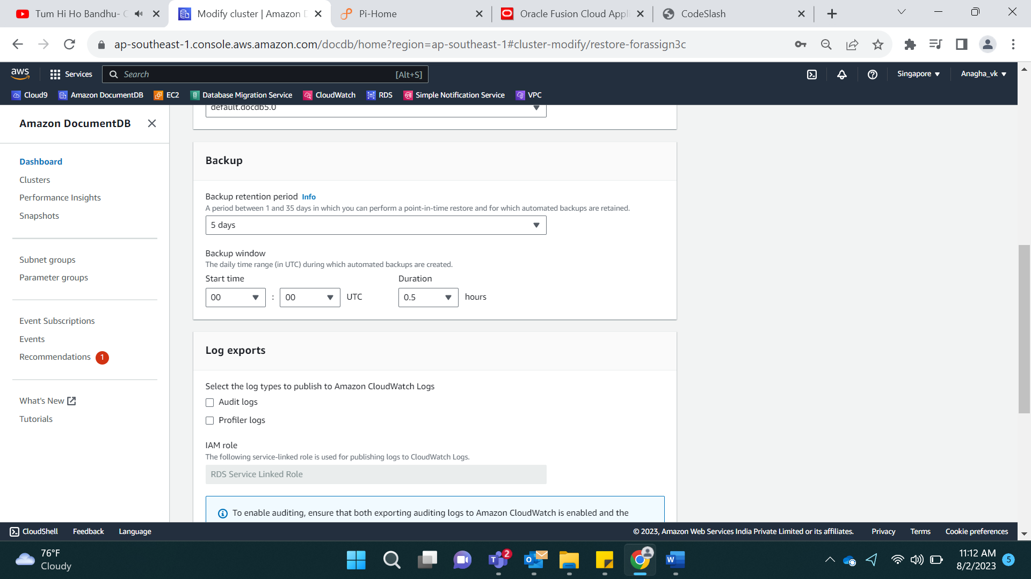

Apply Immediate:

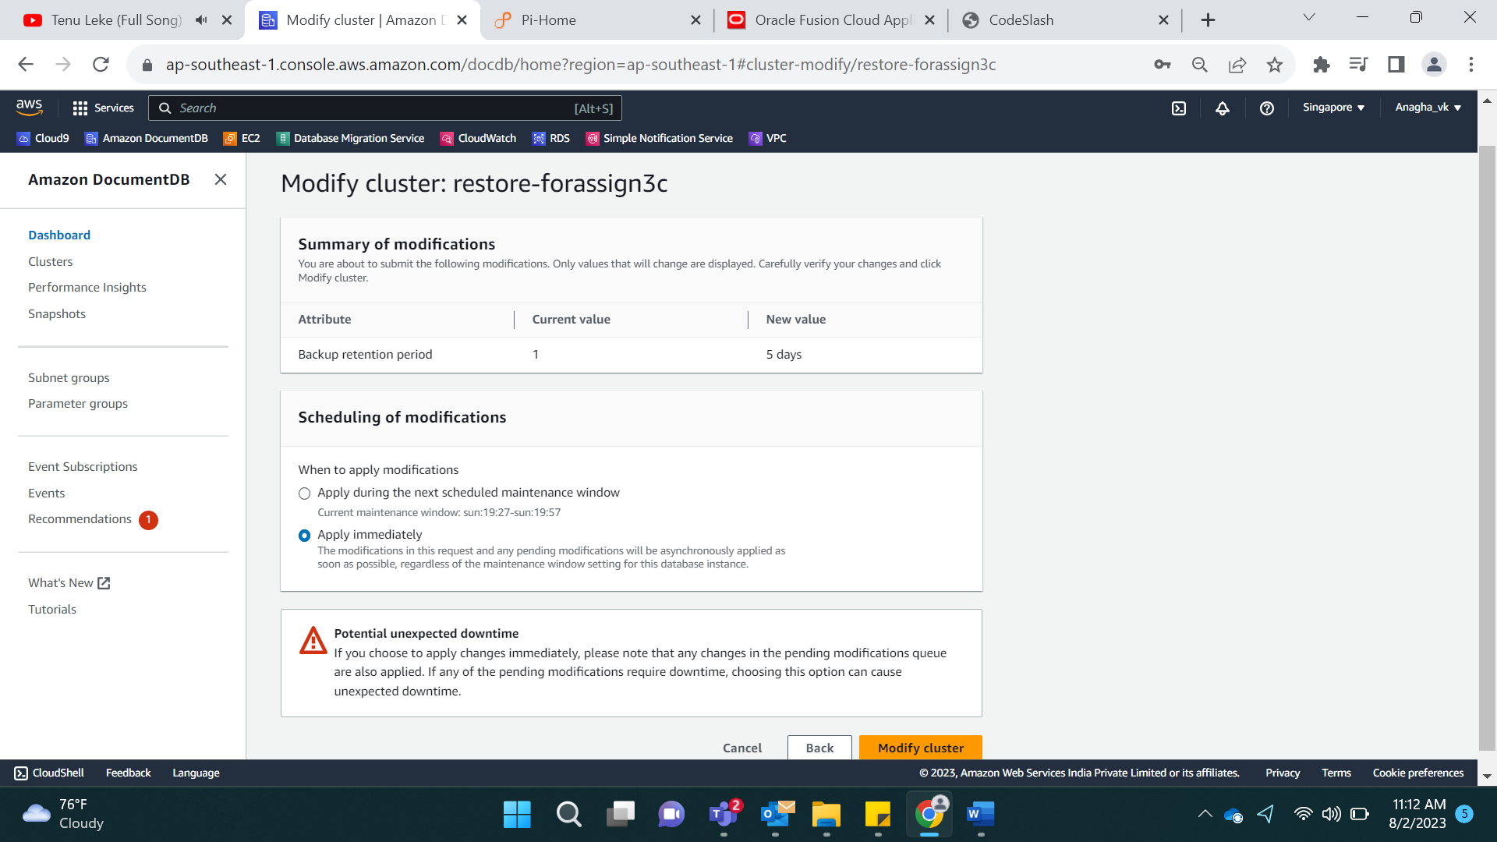

Result:

Its showing cluster is being modified.

